Thailand: Recent Economic Developments and Outlook

# GDP growth in 2019 decreased

GDP growth decreased from 4.2% in 2018 to 2.4% in 2019. On the demand side, private consumption, accounting for 50.1% of GDP, contributed the most with 2.2 percentage points (pp). Net exports shared 0.8pp. Government expenditure shared 0.2pp. On the other hand, gross capital formation cut 0.9pp from growth. On the supply side, services, accounting for 58.6% of GDP, contributed the most with 2.5pp. Meanwhile, industry (including construction) and agriculture had trivial contribution to growth this period.

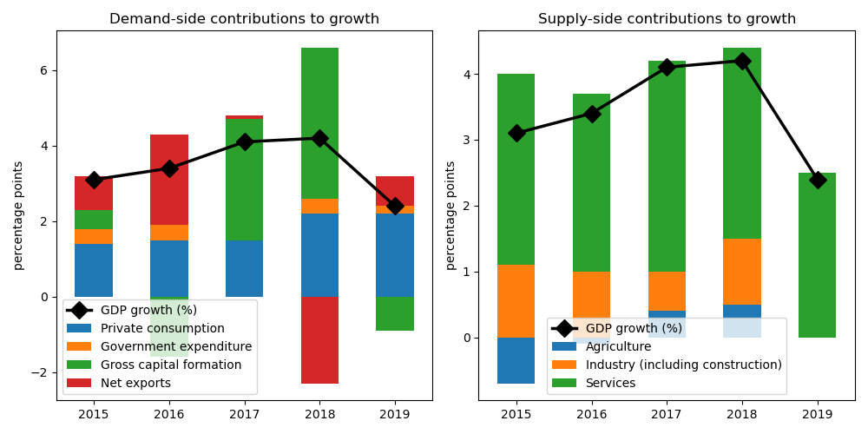

## Net exports achieved largest gain on the demand side

Net exports expanded by the biggest margin at 11.5% annual growth. Private consumption grew by 4.5%. Government expenditure grew by 1.4%. On the other hand, gross capital formation decreased by 3.7%.

## On the supply side, growth in services accelerated the fastest

Services increased by the largest edge at 4.3% annual growth. Agriculture grew by 0.1%. Industry (including construction) increased by 0.1%.

## Unemployment improved; inflation declined

Unemployment rate improved from 0.8% in 2018 to 0.7% in 2019. Consequently, inflation declined from 1.1% to 0.7%. At the end of the year, the central bank set the policy rate at 3.0%.

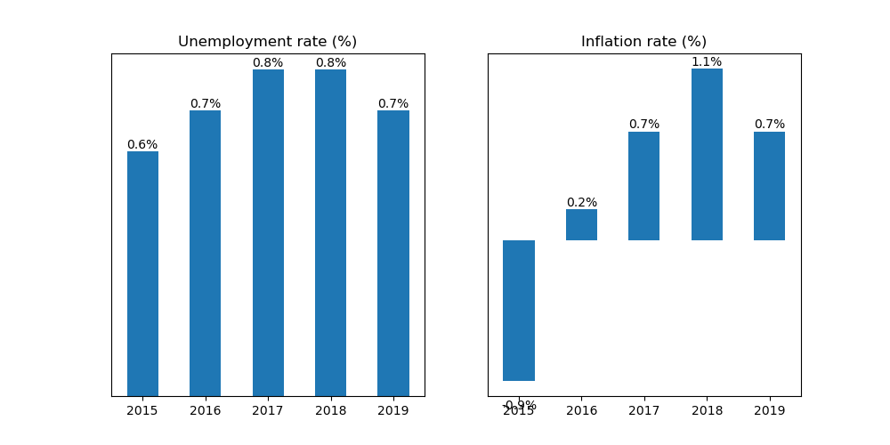

## Current account balance posted a surplus

Current account balance (CAB) recorded a surplus at 7.0% of GDP in 2019. Net trade in goods and services reached USD 50.0 billion. In 2018, CAB posted a surplus at 5.6% of GDP.

USA is the country's top export destination accounting for 12.7% of total exports in 2019. Other major exports partners include China (12.0%), Japan (9.9%), Viet Nam (5.0%), and China, Hong Kong SAR (4.7%). Top export commodities are nuclear reactors, boilers, machinery and mechanical appliances; parts thereof, accounting for 15.8% of total exports.

For imports, top imports origin in 2019 is China (21.1% of total imports), followed by Japan (14.0%), USA (7.4%), Malaysia (5.5%), and Rep. of Korea (3.6%). Major import commodities are electrical machinery and equipment and parts thereof; sound recorders and reproducers; television image and sound recorders and reproducers, parts and accessories of such articles, accounting for 17.9% of total imports.

# Output contracted in Q3 2020

Output plunged by 6.4% year-on-year in Q3 of 2020. Growth in overall economic activity improved from a contraction of 12.2% in the previous quarter. Government expenditure jumped by the biggest margin at 3.4% annual growth. On the other hand, net exports, gross capital formation, as well as private consumption, contracted by 50.2%, 2.5%, and 0.6%, respectively.

## Consumer confidence up

Meanwhile, consumer confidence index was in the positive territory at 46.3 points in Q4 of 2020. Confidence improved from 44.6 points in the previous quarter. Expectations of consumers about the general economic situation in the next 12 months turned optimistic at 60.1 points from 58.5 points over the same period, reflecting improved consumer sentiments.

## Industrial output shrank

Manufacturing shrank by 0.5% year-on-year in October, an increase from -3.4% growth in the previous month.

## Inflation declined

Overall inflation declined to -1.6% year-on-year in October from -1.4% in the previous month.

Thailand's central bank kept the official policy rate to 1.75% in November from the same in October.

# Outlook tilted downwards this year

On November 2020, Consensus Economics panelists project Thailand's economic growth ending in 2020 at -7.7%. In 2021, the panelists foresee growth at 3.9%. Over the same period, consumption is expected to grow by -2.9% and 3.5%, while investment is projected to grow by -7.7% and 5.4%. Industrial production is seen to grow by -9.6% and 5.8%.

Meanwhile, Consensus Economics panelists foresee inflation averaging in 2020 at -0.9%. In 2021, the panelists project inflation at 1.0%.

*Sources: Consensus Economics, The World Bank, UN Comtrade, Haver Analytics, and National Sources. Accessed 05 December 2020.*